**Independent Living Units (ILU)**

**Residential Property Information Sheet**

|  |  |
| --- | --- |
| **Apartment 15**  **Horizon**  **2 x** https://d30y9cdsu7xlg0.cloudfront.net/png/18003-200.png **2 x** https://cdn0.iconfinder.com/data/icons/housicon/512/bathroom-512.png  **Required Life Lease Ingoing Contribution:**  **$665,000**  *The information provide on this Information Sheet was accurate at the time of publishing but is subject to change.*  Version: October 2022 |  |

|  |  |  |
| --- | --- | --- |
| **Design and Features** |  |  |
| * Apartment Living | * Built-in wardrobes | * Fly screens |
| * Senior-friendly design | * Reverse cycle air conditioning | * Balcony |
| * Private balcony | * High ceilings | * Secured single (1) carpark |
| * Spacious Living / Dining | * Electric Cooktop | * Generous storeroom |
| * Modern Kitchen | * Electric Wall Oven | * Dryer |
| * Stone benchtops | * Sliding robe doors | * Laundry |
| * Internal shelved pantry | * Quality floor coverings | * Dishwasher |
| * Quality bathroom(s) | * Block out curtains | * Upgrade options to follow |
|  |  |  |

**Floor Plan**

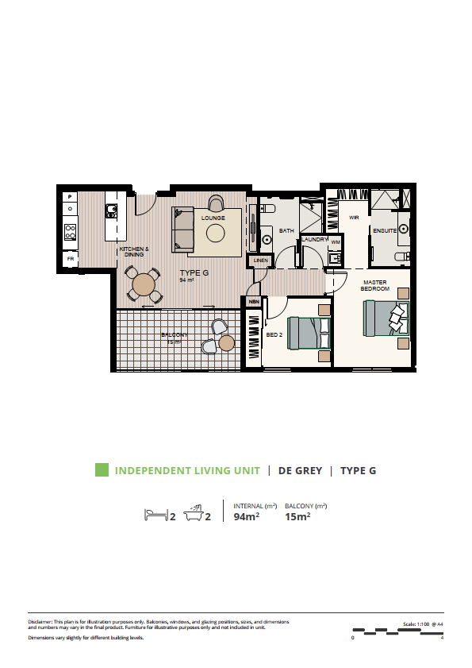

Disclaimer: This plan is for illustration purposes only. Balconies, windows, and glazing positions, sizes, and dimensions and numbers may vary in the final product. Furniture for illustrative purposes only and not included in unit. Dimensions vary slightly for different building levels.

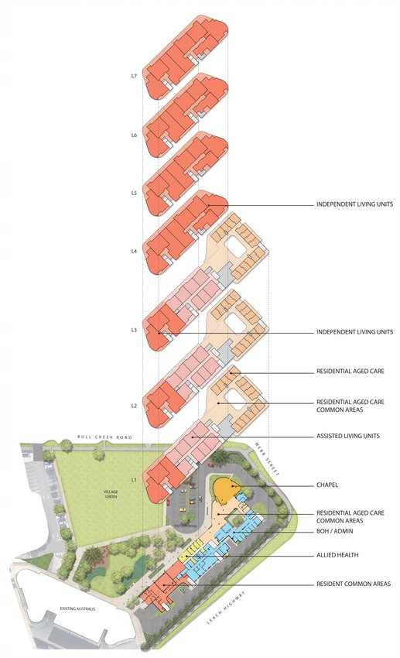**Location Plan**

**Level 4**